# PROJECT DESIGN PHASE-II DATA FLOW DIAGRAM & USER STORIES

|  |  |
| --- | --- |
| Date | 11 October 2022 |
| Team ID | PNT2022TMID08090 |
| Project Name | University Admit Eligibility Predictor |
| Maximum Marks | 4 Marks |

**Data Flow Diagrams:**

A Data Flow Diagram (DFD) is a traditional visual representation of the information flows within a system. A neat and clear DFD can depict the right amount of the system requirement graphically. It shows how data enters and leaves the system, what changes the information, and where data is stored.

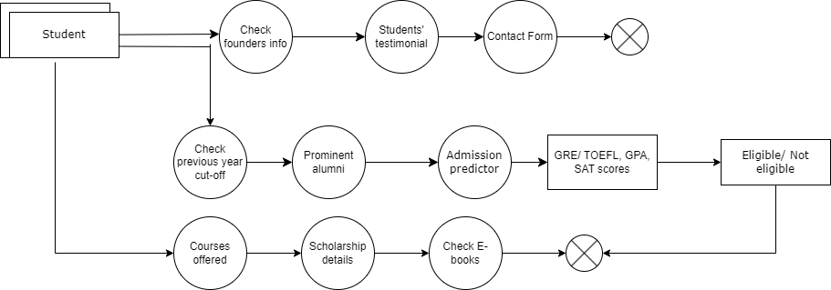

# User Stories

Use the below template to list all the user stories for the product.

|  |  |  |  |  |  |  |
| --- | --- | --- | --- | --- | --- | --- |
| **User Type** | **Functional Requirement**  **(Epic)** | **User Story Number** | **User Story / Task** | **Acceptance criteria** | **Priority** | **Release** |
| Customer | Landing page | USN-1 | As a user, I can view the details about the university | I can access the university landing page | Medium | Sprint-1 |
|  |  | USN-2 | As a user, I can view the latest news  about the university | I can access the latest  news | Medium | Sprint-1 |
|  |  | USN-3 | As a user, I can fill the contact form for  queries | I can fill and submit the  contact form | Low | Sprint-2 |
|  |  | USN-4 | As a user, I can see the social media  profiles of the university | I can reach out to them  via social media | Medium | Sprint-1 |
|  |  | USN-5 | As a user, I can see testimonials of students who graduated from the  university | I can access the testimonials | Medium | Sprint-1 |
|  | Admissions | USN-6 | As a user, I can see the previous year cut- off marks | I can download the previous year cut-off  details | High | Sprint-2 |
|  |  | USN-7 | As a user, I can read about proud alumni of the university | I can access the details  of alumni of the university | Medium | Sprint-2 |
|  |  | USN-8 | As a user, I can predict my eligibility for admission at the university | I can get result as either eligible/not eligible | High | Sprint-2 |
|  | Courses offered | USN-9 | As a user, I can see the courses offered by  the university for PG students | I can access the course  details | Medium | Sprint-3 |
|  | Events | USN-10 | As a user, I can check various technical  events about to happen in the university | I can register for the  events | Low | Sprint-3 |
|  | E-books | USN-11 | As a user, I can download and read e-  books relating to visa formalities | I can download the e-  books | High | Sprint-3 |

|  |  |  |  |  |  |  |
| --- | --- | --- | --- | --- | --- | --- |
| **User Type** | **Functional Requirement**  **(Epic)** | **User Story Number** | **User Story / Task** | **Acceptance criteria** | **Priority** | **Release** |
|  | Scholarship | USN-12 | As a user, I shall find resources regarding scholarship availability | I can access scholarship resources | High | Sprint-4 |
|  | Test prep  materials | USN-13 | As a user, I can download and read GRE,  TOEFL test preparation materials | I can download test  preparation materials | Medium | Sprint-4 |
| Administrator | Landing page | USN-14 | As an administrator, I shall update the  news about the university | I can check if the update  is reflected or not | Medium | Sprint-4 |
|  | Events | USN-15 | As an administrator, I can update the list  of activities to be hosted | I can check if the update  is reflected or not | Medium | Sprint-4 |